What is the VictorReader Trek?

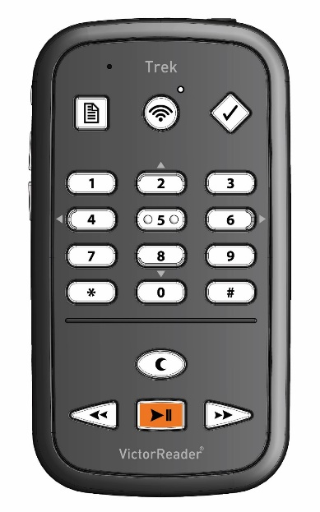

- All-in-one device combining the popular VictorReader Stream and Trekker Breeze
- One simple device to navigate one’s environment or the latest best seller
- Familiar VictorReader interface makes it even easier to obtain environmental information

- Exact same Stream button interface
  - More tactile recognition for certain buttons
- Headphone / microphone jack similar to that found in today’s smartphones
- Significantly improved processor over that found on either the existing Stream or Breeze
  - Faster processing of downloads, map info and environmental data
- Slightly thicker profile to accommodate GPS hardware
- 12-15 hour battery life
- Bluetooth chip
- FM Radio module (Version 1.1)
- Water resistant case
- Bluetooth external speaker with clip
- Exact same functionality as Stream
- All online / offline book reading, downloading and media playback
- Now with Bluetooth integrated users can listen to books, podcasts, or internet radio from their powerful Bluetooth speakers
- Improved headphone / mic jack allows for volume control and play / stop from one’s headphones if such features are supported by the headset (Apple ear pods for example)

- Typical use case:
  - User is taking a bus to work and has an hour commute
  - They tap the online button to enter Orientation mode and Trek guides them to the bus stop
  - While on the bus they tap the online button again to navigate to their talking books and start listening to that best seller they can’t put down
  - There is construction and the bus has to take a detour
  - User taps the online button a couple times, and back in Orientation mode, they press the where am I button and hear the current intersection they are approaching
  - Comfortable with their location, user goes back to listening to their book on the same device

